**Gaamour Adel**

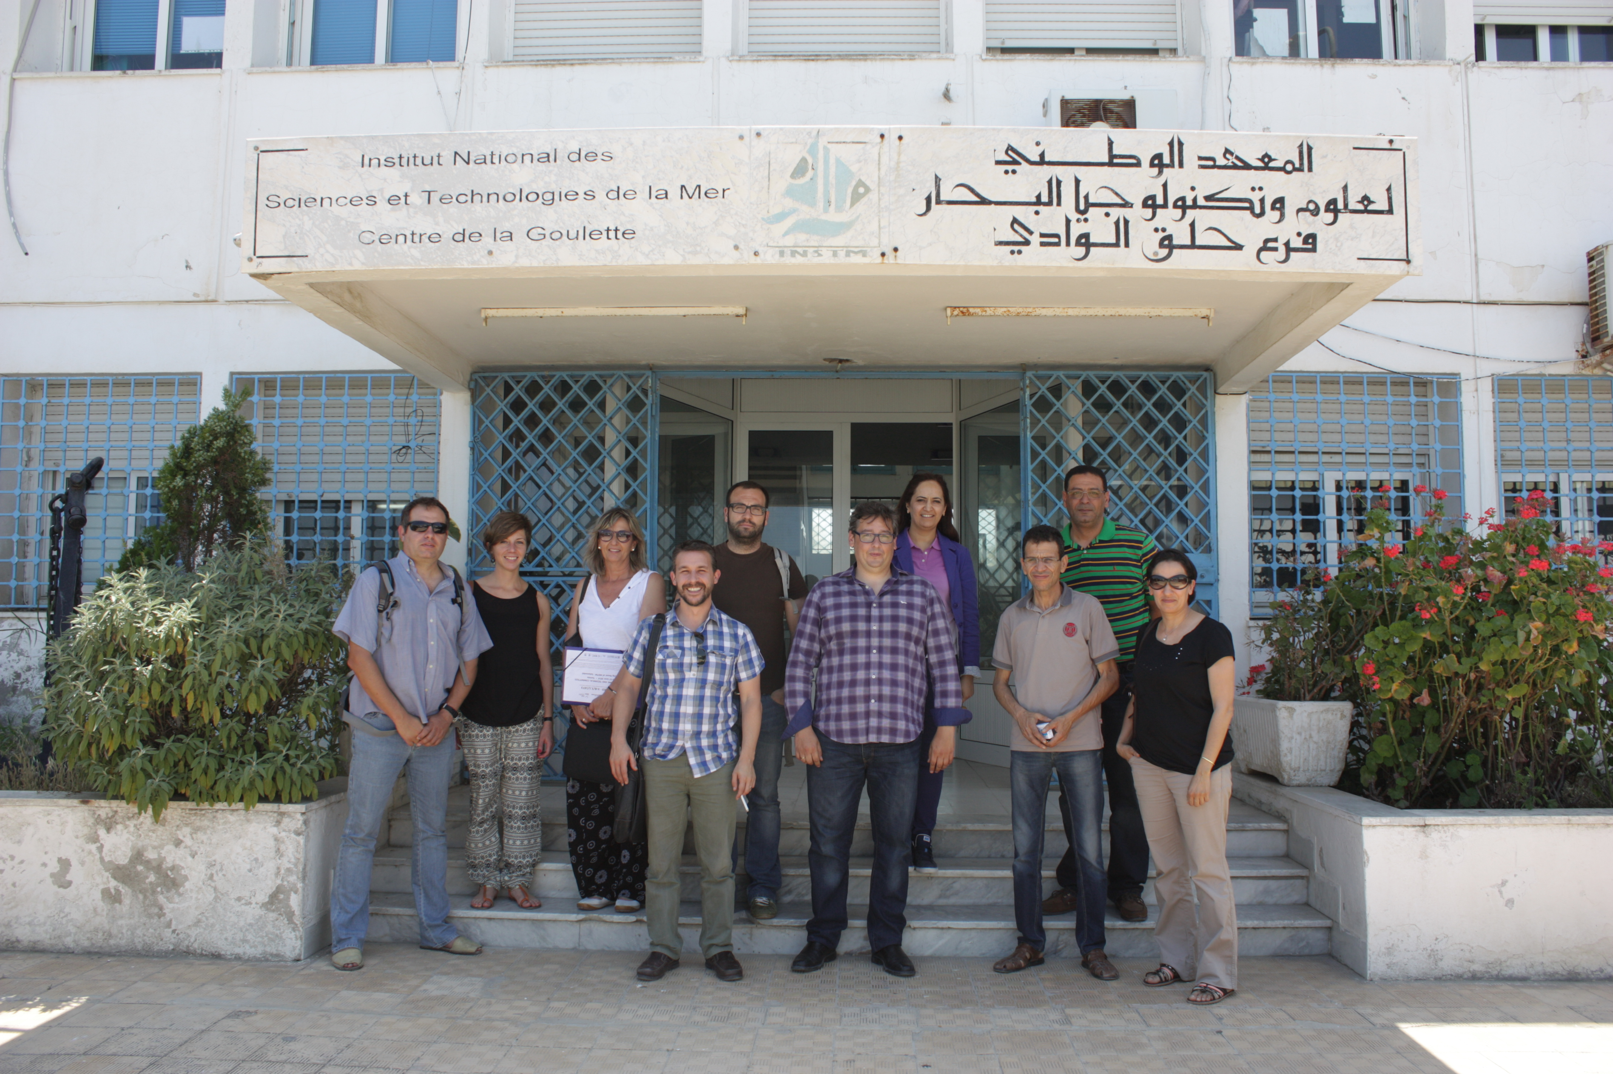**Gaamour Adel** studied at the National institute of agronomy of Tunisia, and obtained the engineering degree in fisheries science's in 1992. He gets respectively a postgraduate degree (D.E.A) in management of coastal ecosystem in term of resources – Oceanographic Biology in 1994 and PhD degree in Oceanographic biology in 1999 from the Occidental University of Bretagne (Brest- France).

Since October 2000, he was recruited as a researcher at the INSTM (National Institute of Marine Sciences and Technologies of Salammbô - Tunisia). He works on the eco-biology of exploited marine resources, fishing métiers analyzes and management of fisheries in particular those of Spiny lobster, red coral and small pelagic resources. The global objective of his researches is to enable economic and social development based on the promotion of the sustainable use of Tunisian fisheries resources. Since 2003, he is in charge of the coordination of INSTM National project dealing with biology and stock assessment of pelagic marine resources, red spiny lobster and red coral. Additionally, he has been involved among others in FAO-Copemed and FAO-MedSudMed projects. Currently he is Project Coordinator of the INSTM Partner for the 2014-2015 ENPI-EU Project entitled ECOSAFIMED - Towards Ecosystem Conservation and Sustainable Artisanal Fisheries in the Mediterranean basin.